Project Planning Phase
Project Planning Template (Product Backlog, Sprint Planning, Stories, Story points)

Date | 24 June 2025
Team ID | LTVIP2025TMID21049
Project Name | Flight finder-navigating your air travel options
Maximum Marks | 5 Marks

Product Backlog, Sprint Schedule, and Estimation (4 Marks)
Use the below template to create product backlog and sprint schedule
Sprint | Functional  Requirement (Epic) | User Story  Number | User Story / Task | Story Points | Priority | Team  Members
Sprint-1 | Data Collection | USN-1 | Collect data from various APIs/sources | 2 | High | 1
Sprint-1 | Data Collection | USN-2 | Load collected data into storage/memory | 1 | High | 2
Sprint-1 | Data Preprocessing | USN-3 | Handle missing values in dataset | 2 | Low | 3
Sprint-1 | Data Preprocessing | USN-4 | Convert/encode categorical data | 2 | Medium | 4
Sprint-2 | Model Building | USN-5 | Build a machine learning model to recommend or classify flights | 5 | High | 1
Sprint-2 | Model Building | USN-6 | Test model accuracy and performance | 3 | High | 2
Sprint-2 | Deployment | USN-7 | Design working HTML pages for frontend | 3 | Medium | 3
Sprint-2 | Deployment | USN-8 | Deploy using Flask and integrate model | 5 | High | 4

Project Tracker, Velocity & Burndown Chart: (4 Marks)
Sprint | Total Story Points | Duration | Sprint Start Date | Sprint End Date (Planned) | Story Points  Completed (as on  Planned End Date) | Sprint Release Date (Actual)
Sprint-1 | 8 | 5 Days | 17 June 2025 | 21 June 2025 | 8 | 21 June 2025
Sprint-2 | 16 | 5 Days | 22 June 2025 | 26 June 2025 | 16 | 26 June 2025

Velocity:
Imagine we have a 10-day sprint duration, and the velocity of the team is 20 (points per sprint). Let’s calculate the team’s average velocity (AV) per iteration unit (story points per day)
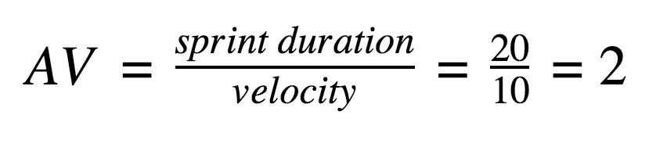

Burndown Chart:
A burn down chart is a graphical representation of work left to do versus time. It is often used in agile software development methodologies such as Scrum. However, burn down charts can be applied to any project containing measurable progress over time.

https://www.visua
l
-
paradigm.com/scrum/scru
m
-
burndow
n
-
chart
/

https://www.atlassian.com/agile/tutorials/burndow
n
-
chart
s

Reference:

t
https://www.atlassian.com/agile/projec
-
managemen
t

https://www.atlassian.com/agile/tutorials/ho
w
-
t
o
-
d
o
-
scru
m
-
wit
h
-
jir
a
-
softwar
e

https://www.atlassian.com/agile/tutorials/epic
s

https://www.atlassian.com/agile/tutorials/sprint
s

https://www.atlassian.com/agile/projec
t
-
management/estimatio
n

https://www.atlassian.com/agile/tutorials/burndow
n
-
chart
s

